
Quantum Computing:
From Qubit Manipulation to Applications
in Molecular Physics

Objective of the module is to introduce students to the fundamental principles of quantum computing. The module covers the core concepts of qubits and quantum states, with emphasis on the phenomena of quantum superposition, entanglement, decoherence, and quantum measurement, and their implications for information processing. The foundational postulates of quantum mechanics underlying quantum computing are analyzed to provide a rigorous theoretical framework for these concepts. Students will explore quantum gates and quantum circuits as the building blocks of quantum algorithms. Practical implementation of these concepts will be demonstrated using a Python-based quantum computing library, enabling hands-on experience in designing and simulating quantum circuits. Real-world applications of quantum computing will be illustrated through example exercises, including quantum cryptography, to highlight the advantages and challenges of quantum approaches to secure communication.

Activity with the interface:
https://qtechedu.centralesupelec.fr/EN/ex9.html

1. Introduction:
- Define quantum computing and explain how it differs from classical computing. What classes of problems are expected to be solved more efficiently using quantum algorithms?
- List several well-known quantum algorithms and briefly describe the types of problems they are designed to solve.
- Define a qubit. Compare it with a classical bit. Then represent a general one-qubit state using at least two different notations.
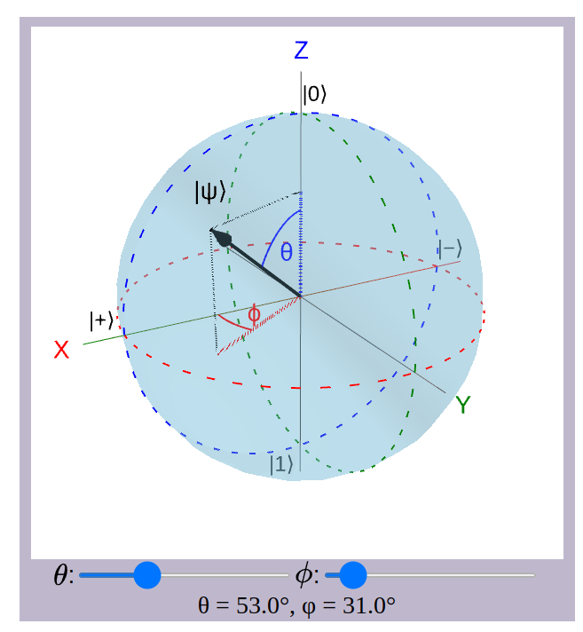
- What condition must the coefficients of a qubit satisfy? Why is this condition important?
- Using an interactive Bloch sphere, choose specific values for the angles θ and ϕ, and:
- Explain what the Bloch sphere represents;
- Describe the position of the state vector on the sphere;
- Write the mathematical expression of the qubit state using the chosen angles;
- Express the same state in Dirac and Vector notations.
2. Fundamental Concepts of Quantum Computing
- List the main properties of a qubit and provide a definition for each of them.
- Superposition:
- What does the principle of superposition mean for (a) a single qubit, for (b) a multi-qubit system?
- Explain what it means for a qubit to be in a superposition of ∣0⟩ and ∣1⟩. How is this different from a classical bit?
- How is a general (a) a single-qubit (b) n-qubit state mathematically represented? What condition must the coefficients α_{i} satisfy in a quantum state?
- For an n-qubit system, how many computational basis states exist, and why?
- What is the tensor product, and how is it used to construct multi-qubit states? Express the state ∣q₁q₂…q_{n}⟩ using tensor product notation.
- In the state ∣01⟩, what do the individual qubit states represent?
- List all computational basis states for a two-qubit system. Write the most general state of a two-qubit system using the principle of superposition.
- How can a two-qubit state be written in column-vector form? What is the vector representation of the basis state ∣10⟩?
- How does the principle of superposition relate to the postulates of quantum mechanics?

- Measurement:
- What is the role of measurement in quantum mechanics?
- What is a measurement operator M_{m}, and how is it defined for a projector?
- What is the Born rule, and how does it determine measurement probabilities?
- How is the probability p(m) expressed in terms of inner products?
- Why is the probability always a real number between 0 and 1?
- What happens to a quantum state after measurement?
- Write the formula describing state collapse after obtaining the measurement outcome m?
- Why is quantum measurement probabilistic?
- What are partial measurements and when are they important?
- Why are multiple runs (shots) needed in quantum computing?
- Which postulate of quantum mechanics describes measurement?
- What are the Pauli matrices? How are they used as measurement observables?
- Describe the properties of the Pauli matrices and explain their role in quantum measurements.
- What are the possible outcomes when measuring a qubit using the Pauli-Z operator?

- Entanglement:
- What is quantum entanglement?
- Why is entanglement considered a uniquely quantum phenomenon?
- What does it mean that one qubit cannot be described independently of another?
- What condition distinguishes separable states from entangled states using tensor products?
- What are the Bell states? Write the four Bell states explicitly.
- Why are Bell states considered maximally entangled?
- What happens when one qubit of an entangled pair is measured? How are the measurement outcomes of the two qubits correlated?
- Why does measurement cause collapse of the joint state?
- Why is entanglement considered a resource in quantum computing?
- Name several applications that rely on entanglement.
- Which postulate explains entanglement?
- How does measurement (postulate of measurement) affect entangled states?

- Quantum Gates:
- What are quantum gates? How are quantum gates similar to classical logic gates?
- What role do quantum gates play in quantum computing?
- What mathematical object represents a quantum gate?
- How does a quantum gate transform a quantum state?
- What condition must a quantum gate satisfy? Why must quantum gates be unitary?
- Which postulate of quantum mechanics describes the evolution of quantum gates?
- What are the properties of the Identity gate?
- What do the Pauli-X, Pauli-Y, and Pauli-Z gates do?
- What is the role of the Hadamard gate?
- How does the Hadamard gate create superposition?
- What happens when a Hadamard gate is applied to the state ∣0⟩?
- Explain the action to the qubit the T, S and phase gates on a qubit.
- What does the CNOT gate do?
- How can the Hadamard and CNOT gates be used to create entanglement?
- How do the Pauli gates act on the Bloch sphere?
- What does the SWAP gate do?
- What is the difference between a classical NOT gate and a quantum Pauli-X gate?

(6) Bloch Sphere Visualization of Quantum Gates
In the page of the module https://qtechedu.centralesupelec.fr/EN/ex9.html you can select a quantum gate from the list (marked 1 in the figure below) and visualize them action to qubit using the Bloch sphere (marked 2 in the figure below).
Based on this interactive representation, answer the following questions for a selected quantum gate.
1) Describe the properties of the selected gate and explain how it affects a qubit.
2) Write down the matrix representation of the selected gate.
3) Write down the default initial state of the qubit. Apply the selected gate to the qubit using the Apply gate button (marked 3 in the figure below), and write down the final state in Dirac notation.
4) Using the Bloch sphere sliders (marked 4 in the figure below), modify the initial state of the qubit and apply the selected gate again. Write down the initial state and the final state in Dirac representation.
5) Demonstrate this transformation mathematically in detail using the expressions provided on the website.

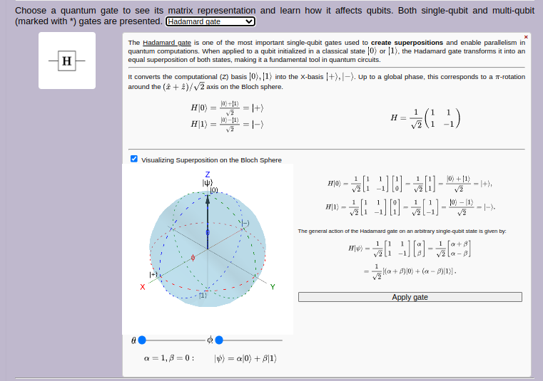
1
2
4
3

3. Problem-Solving Exercises
        - Measurement probabilities: A qubit is in the state: ∣ψ⟩=(∣0⟩ + ∣1⟩). What are the probabilities of measuring ∣0⟩ and ∣1⟩?
        - Superposition and entanglement: A two-qubit system is in the state ∣ψ⟩= (∣00⟩ + ∣01⟩ + ∣10⟩ + ∣11⟩). How many classical basis states does this state represent simultaneously? Is this state entangled ?
        - Separability test: Consider the two-qubit state: ∣ψ⟩= (∣00⟩+∣11⟩). Is this state separable or entangled?
        - Measurement on entangled state: Consider the Bell state ∣Ψ⁺⟩=(∣01⟩ + ∣10⟩). If the first qubit is measured and found in ∣0⟩, what is the state of the second qubit?
        - Compute probabilities: Consider the state ∣Φ⁺⟩=(∣00⟩ + ∣11⟩). What is the probability of measuring ∣00⟩? What is the probability of measuring ∣11⟩?
        - Reduced density matrix: Consider the Bell state ∣Φ⁺⟩=(∣00⟩ + ∣11⟩). Show that subsystem A is mixed by computing the reduced density matrix ρ_{A}.
        - Correlation after measurement: Consider the state ∣Φ⁻⟩=(∣00⟩−∣11⟩). If the first qubit is measured as ∣1⟩, what happens to the second qubit?
        - General separability condition: Consider the general two-qubit state ∣ψ⟩ = a∣00⟩ + b∣01⟩ + c∣10⟩ + d∣11⟩. What condition must hold for the state to be separable?
        - Partial measurement: Consider the state ∣Φ⁻⟩=(∣01⟩−∣10⟩). Measure the second qubit and obtain ∣0⟩. What is the new state of the two-qubit system?
        - Measurement using the Pauli-Z operator: Measure the first qubit of the state ∣Φ⁺⟩=(∣00⟩ + ∣11⟩). What are the possible measurement outcomes and their probabilities?
        - Which quantum postulates are involved in entanglement and measurement in these problems?
4. In the last section, “Application: VQE Algorithm for Eigenvalue Problems“, of the module (https://qtechedu.centralesupelec.fr/EN/ex9.html), the possibility of using a quantum computer in molecular physics is demonstrated through the calculation of the ground-state energy of the H₂ molecule using the Variational Quantum Eigensolver (VQE) method.
(1) Briefly explain the principle of the VQE algorithm. What type of computational problems and physical systems can be studied using VQE?
(2) Describe the main stages of the VQE algorithm. Illustrate the interaction between the quantum and classical parts of the algorithm.
(3) Choose and enter the required simulation parameters:
- basis set,
- ansatz,
- type of classical optimizer,
- range of interatomic distances r,
- maximum number of iterations of the classical optimizer,
- number of points.
Run the simulation using the “Run VQE” button.
(4) Analyze the obtained results. Describe the potential energy curve of the H₂ molecule and compare the convergence behavior of the optimization process at different selected points.
(5) Modify one of the simulation parameters and compare the new results with the previous calculation.
Discuss how this parameter affects:
- convergence,
- accuracy,
- computational cost,
- shape of the potential energy curve.
(6) In the tab “Visualisation of the Ground-State Optimisation Process”, the video demonstrates the relationship between the evolution of the qubit state on the Bloch sphere and the minimization of the molecular energy during the VQE optimization process. Explain how these quantities evolve during the optimization process in the molecular orbital basis. What do the basis states ∣1100⟩ and ∣0011⟩ represent in the molecular orbital basis?
(7) In the section “Complete Procedure to Compute the Ground-State Energy of H₂ Using VQE”, identify the qubit Hamiltonian and the ansatz corresponding to the chosen basis.

